VUB June Newsletter

VUB Student Highlights

Congratulations to all VUB Graduates!!!
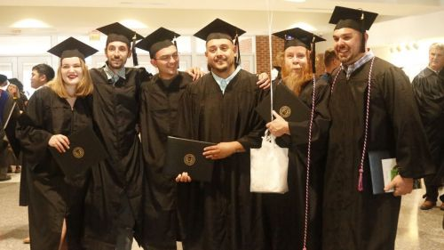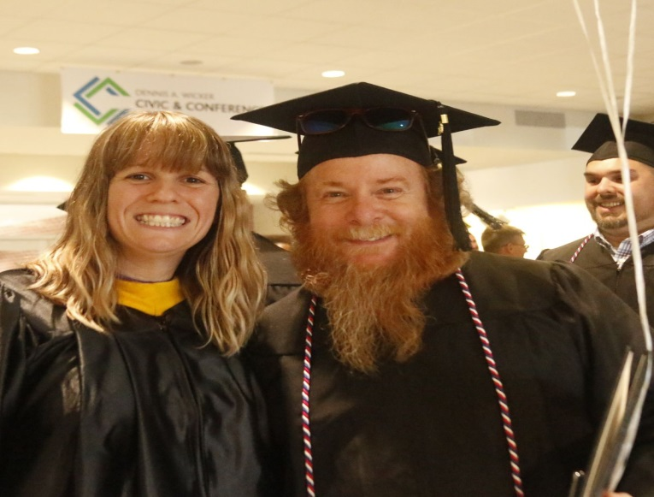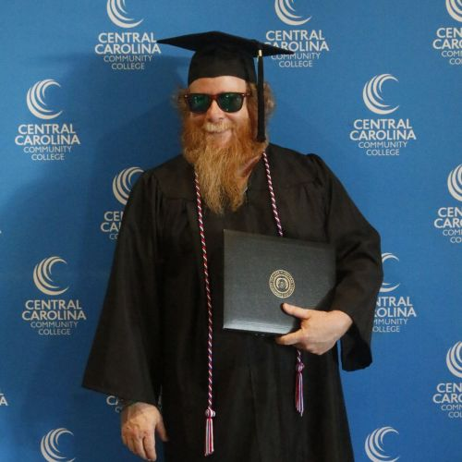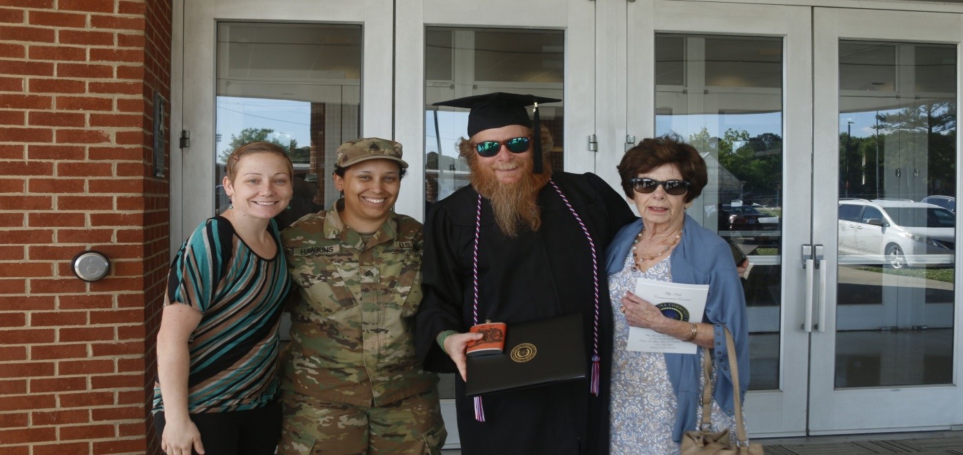
Join us in Congratulating both Russell Wampler and Anthony Biggs on completing the Motorcycle Mechanics Certificate at CCCC.
Campbell University Campus Tour
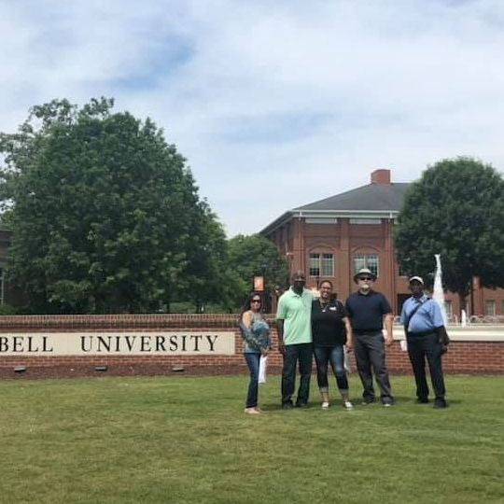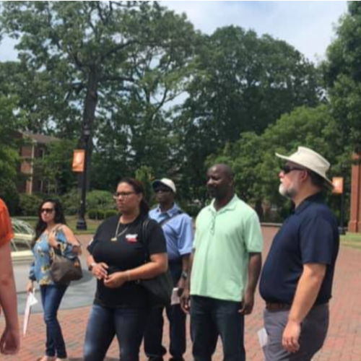
VUB Students enjoyed a tour of Campbell University and learned everything that CU has to offer!

Summer Classes are Here!
CCCC LEE CAMPUS
MATHEMATICS REFRESHER COURSE: June 11 – June 20, 2019
Instructor: TBA
LOCATION: CCCC LEE CAMPUS, CFC (Fitness) Room 814
DAYS: Tues/Thurs
TIME: 6:30-8:00 pm
LITERATURE AND COMPOSITION REFRESHER COURSE: July 9 – July 18, 2019
Instructor: TBA
LOCATION: CCCC LEE CAMPUS, CFC (Fitness) Room 814
DAYS: Tues/Thurs
TIME: 6:30-8:00 pm
BASIC COMPUTER SKILLS REFRESHER COURSE: August 6 – August 15, 2019
Instructor: TBA
LOCATION: CCCC LEE CAMPUS, CFC (Fitness) Room 811
DAYS: Tues/Thurs
TIME: 6:30-8:00 pm
INTRO TO SPANISH REFRESHER COURSE: July 23 – August 1, 2019
Instructor: TBA
LOCATION: CCCC LEE CAMPUS, CFC (Fitness) Room 814
DAYS: Tues/Thurs
TIME: 6:30-8:00 pm

WTTC NORTHERN CAMPUS
MATHEMATICS REFRESHER COURSE: June 11 – June 20, 2019
Instructor: Phillip A. Ershadi
LOCATION: WTCC NORTH CAMPUS (VETERANS CENTER)
DAYS: Tues/Thurs
TIME: 6:30-8:00 pm
BASIC COMPUTER SKILLS REFRESHER COURSE: August 6 – August 15, 2019
Instructor: TBA
LOCATION: WTCC NORTH CAMPUS (VETERANS CENTER)
DAYS: Tues/Thurs
TIME: 6:30-8:00 pm

To Register for Classes Use this Link: REGISTER TODAY

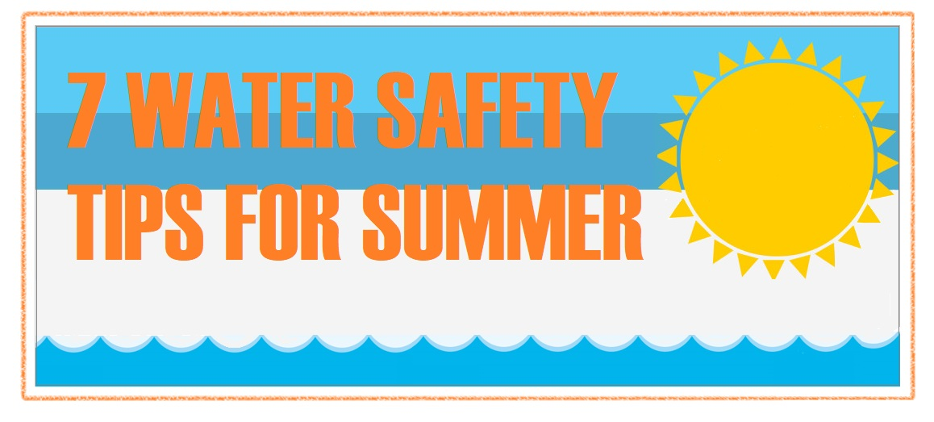
Water safety is everyone's responsibility.
Follow these safety tips to ensure a day on the water is both fun and safe.

- Wear proper attire: Inexperience swimmers can safely enjoy the water by wearing a U.S. Coast Guard approved flotation device, such as a life jacket.
- Swim in monitored areas: Lifeguards prevent many potential water related accidents. Whether you swim at the beach or the pool, make sure to swim in well marked and monitored areas.
- Watch your head: Head and spinal injuries occur most often in shallow water. Stay safe; avoid diving into shallow or murky water.
- Avoid alcohol use: Don't drink and swim. Alcohol impairs one's judgement, coordination and ability to stay warm.
- Teach children to swim: Drowning is one of the most common cause of accidental death among children. Learning to swim is not only fun, but is a lifesaving skill.
- Take a friend: Always swim with a buddy. Even experienced swimmers can tire or get muscle cramps.
- Active supervision: Keep eye out on children around water. Stay within reach.

Did you know CCCC now has Veteran Student ID's?
Swing by the library (Lee main campus) and get yourself a new ID. You will need proof of Military Service (DD 214, VA card, or DL with Veteran Status).

Did you know CCCC now has Veteran Student ID's?
Swing by the library (Lee main campus) and get yourself a new ID. You will need proof of Military Service (DD 214, VA card, or DL with Veteran Status).

Dates to Remember:

June 11 – June 20, 2019 -MATHEMATICS REFRESHER COURSE (WTCC-NORTH)
August 6 – August 15,2019: BASIC COMPUTER SKILLS REFRESHER COURSE (WTCC-NORTH)
June 11 – June 20, 2019: MATHEMATICS REFRESHER COURSE(CCCC)
July 9 – July 18, 2019: LITERATURE AND COMPOSITION REFRESHER COURSE (CCCC)
August 6 – August 15, 2019: BASIC COMPUTER SKILLS REFRESHER COURSE (CCCC)
July 23 – August 1, 2019: INTRO TO SPANISH REFRESHER COURSE(CCCC)

Follow/Like us on Social Media:

Facebook
Instagram
Twitter
VUB Website

