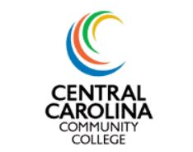

2015-2016 Summer
Financial Aid Facts

- State funds are not available during the summer term. (NCCCG,NCELS)

- A completed 2015-16 FAFSA must be on file with CCCC.

- Full-time enrollment status for all terms is 12 credit hours.

- Students must be accepted into an approved certificate, diploma or associate degree program.

- New and returning students must have remaining eligibility for the current academic year.

- Financial aid is prorated based on enrollment status.

- Financial aid funds do not pay for classes outside the primary major.

- In the event anticipated financial aid cannot be awarded, students are responsible for charges made to the community college.

- If student is currently on Financial Aid Warning or Probation and registers for the 2016 summer semester:
- financial aid cannot be used to charge books, fees or tuition (Be prepared to pay out of pocket)
- aid will be placed on the student record after spring grades have been verified and SAP and eligibility has been determined

