Adding a Survey Link to Your Blackboard Course Site
You will soon receive an e-mail proving the links to your course evaluation. There are several ways for your students to access the course evaluation through your Blackboard course site. In this tutorial we will look at adding the survey through an announcement or button in your course menu.

Through a Blackboard Announcement

- Log into your Blackboard account.
- Click on your course site link.
- Click the Create Announcement button.
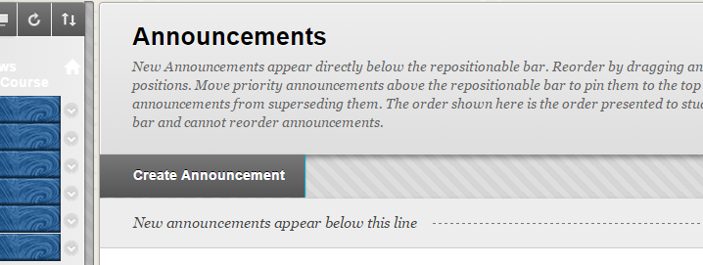

- Enter a subject (for example: CCC 110 Course Evaluation).
- Paste the following text:
In keeping with our efforts to improve the quality of education, Central Carolina Community College regards student evaluations of instructors and courses as extremely important. CCCC asks that you evaluate this course and the instructor’s teaching techniques, evaluation process, and interactions with students. Your instructor will NOT see this evaluation form. Please complete the evaluation for this course by clicking the link below and selecting your instructor's name from the list:

Click here to take the survey.

- Highlight the text “Click here to take the survey.”
- Click the Insert/Edit Link button 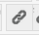.

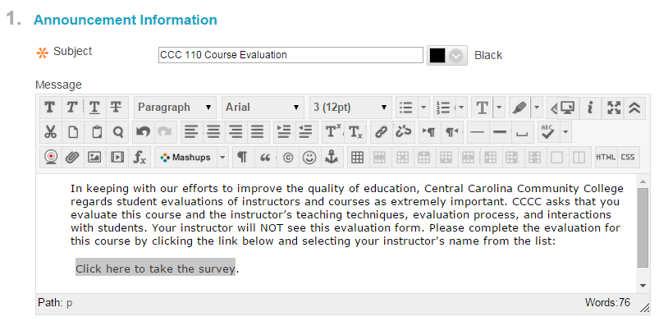

- An “Insert/Edit Link” window will appear once you click the button.
- Navigate to your e-mail and copy the survey link.

- Clear the “Link Path” box and paste the link.
- Click Insert.
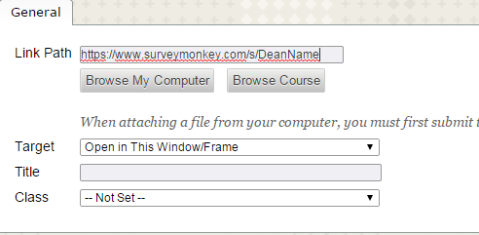
- In “Web Announcement Options,” select both Display after and Display until.
- Enter the start and end dates for the survey.
- Click Submit.

Through a Blackboard Button

- Log into your Blackboard account.
- Click on your course site link.
- Click Add Menu Item button.
- Click Manage Course Menu.
- Click External Link option from the drop down menu.
- Enter the name of the button (for example: “Course Evaluation”).
- Copy the survey link.
- Paste the link in to the box labeled “URL.”
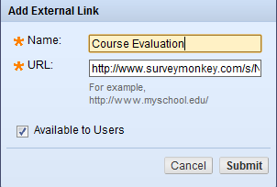
- Check “Available to Users.”
- Click Submit.

