How to Read a Transcript
Example Transcript

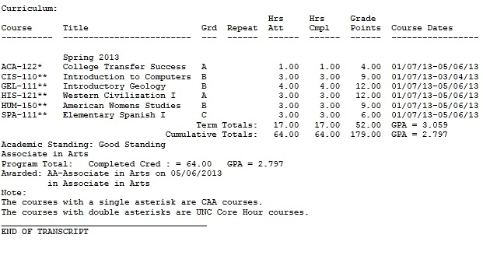

Explanation

Hrs Att: Credit hours attempted

Hrs Cmpl: Credit hours that were completed

Grade points: Also known as QPA (quality point average)

Term Totals: The total credit hours earned for the given semester
Term Total G.P.A: G.P.A for the given semester

Cumulative Totals: The total credit hours earned.
Culumative G.P.A.: Overall G.P.A. for all semesters.

Academic Standing: A student will see if they are in “Good Standing,” “President’s List.” “Dean’s List,” or “Academic Probation.”

Program Total: Calculates the completed credit hours and the Overall Cumulative G.P.A
Awarded: Will list the degree awarded to the student on the date it was awarded.

Any class that has one asterisk means: The course qualifies to transfer to the institutions in the North Carolina Community College System.

The Comprehensive Articulation Agreement (CAA) addresses the transfer of students between institutions in The North Carolina Community Colleges System (NCCCS) and from that system to constituent institutions of the University of North Carolina (UNC). This Comprehensive Agreement was jointly developed by faculty and administrators of the NCCCS and UNC System based on the proposed transfer plan approved by both governing boards in February 1996. The CAA applies to all North Carolina community colleges and all constituent institutions of The University of North Carolina.
Any class that has a double asterisk means: The class will transfer to any UNC institution as a core hour course.

