VETERANS AFFAIRS NEWSLETTER  Fall 2022 | 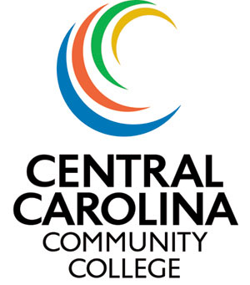

Important things to remember when registering students using  VA Educational Benefits:  - The VA will only pay for courses that are needed to complete the student’s current Program of Study.  - All remedial/developmental classes must be seated classes to be eligible to use VA benefits.  - If a student has previously passed a course the VA will not pay for them to take again to improve their grade.  - Students receiving monthly housing stipends from the VA must be full time and in at least one seated class to receive all of the housing.  - Here are the numbers the VA considers full time:  16-week Term – 12 Credit Hours  12-week Term – 12 Credit Hours  10-week Term -- 7 Credit Hours  8-week Term – 6 Credit Hours  VA Coordinator-Angie Estes-7322  aeste980@cccc.edu | In case you didn’t know:  - There is a very small window of time to inform the VA of any changes to a student’s enrollment. This affects the school as well as some of the payments to the student. Even if it is just a one credit hour class, it can impact the student’s payments. Please be sure turn in Last Date of Attendance to Chris in the Registrar’s Office in a timely manner so that we can report these changes to the VA .  - Any time a student changes their program of study, the VA must be informed. If a student is changing their Program of Study, please remind them to let the VA Coordinator know.  - We currently have approximately 250 students who are using VA Benefits  Thank you for all you do to help our Veterans and their Dependents so they can complete their educational journey.

