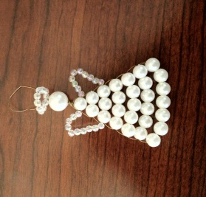
Luminary and Torch Form
CCCC Relay for Life 2012
This holiday season you can help light the way to a cure for cancer and honor or memorialize loved ones who have battled cancer. This year the CCCC Relay for Life team is selling luminaries with a special gift for the Christmas season. Support the American Cancer Society and honor a loved one by purchasing a white luminary bag for $15 each or three for $40.
During the American Cancer Society Relay for Life Event, a beautiful and touching Luminaria Ceremony takes place. Flames of HOPE are lit at nightfall to honor cancer survivors or in remembrance of those who have lost their battle with cancer. These flames burn throughout the night, serving as a reminder of the purpose of Relay for Life.
In addition to your purchase of a luminary during the May 2012 event, you will also receive an angel ornament (see above) and a card with your honored loved one’s name on it. We will also send a card to the loved one or the family of your loved one to share that a luminary has been purchased in his or her honor.
To purchase, please fill out the form below and send it to Amanda Carter, Distance Education, Lee Campus. We can accept cash and checks made out to the American Cancer Society.
#1– Your Name:  In Memory of:  In Honor of:  Address to send card to family: | #2 – Your Name:  In Memory of:  In Honor of:  Address to send card to family:
#3 – Your Name:  In Memory of:  In Honor of:  Address to send card to family: | #4 – Your Name:  In Memory of:  In Honor of:  Address to send card to family:

