What is a Screencast? 2
Screencasting Using Screencast-O-Matic 3
Saving the Video File 4

What is a Screencast?

A screencast is a video recording that allows instructors to record their screen and/or webcam. A screencast is a crucial component of online learning as it allows instructors to

- record a lecture for students
- provide a tour of the course
- demonstrate websites, software, or other computer software used in the course
- record a welcome video

One example of a common screencast is a welcome video. The screenshot below shows an instructor recording the computer's webcam and the screen. The screen displays a powerpoint presentation while the webcam shows the instructor speaking. These videos go beyond text instructions and introduction and help students see their instructor as a real person.

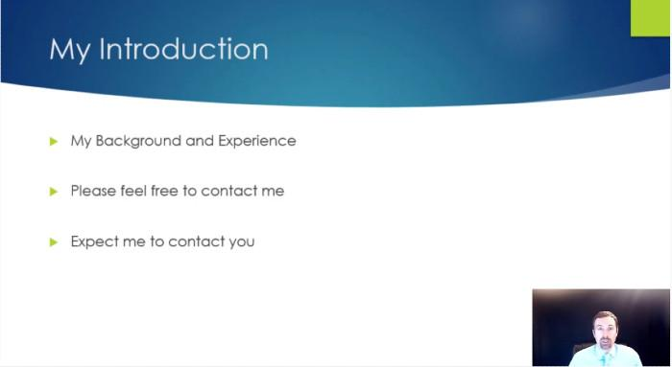

Consider the subjects that you teach. What are ways that you could use this technology in your course to create more engaging learning material for students.

Once you have a few ideas, make a screencast to see how easy, yet effect, they can be.

Screencasting Using Screencast-O-Matic

Start by going to https://www.screencast-o-matic.com/
No account creation is needed. You can start recording right away.
Click the “Record for Free” Button, then “Launch Free Recorder”.
A dialog box with a button stating “Open Screen Recorder Launcher v2.0” appears, click the button.
A recording panel opens. Three choices appear at the top of the panel Screen, Webcam, and Both. Select what you want to record.
A small red button appears in the bottom left corner, press it to record your video and begin.
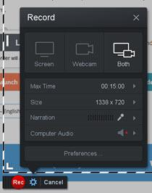

Press the Pause Button (||) to pause the recording. Click Done on the far right of the panel when finished.
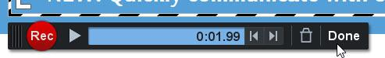

Saving the Video File

After pressing Done, click Save/Upload in the What’s Next? Menu. Save the video file to your computer, then upload the video to YouTube to distribute to your class.
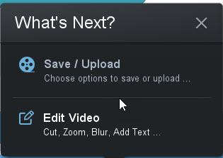

Next, Select Save as Video File

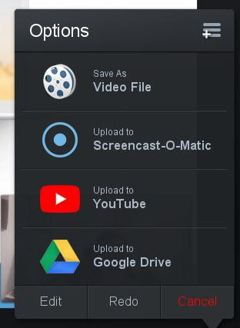

Finally, click the Filename area and give the file a name. Change the Folder location to a desirable location on your computer. Then click the large, green Publish button.
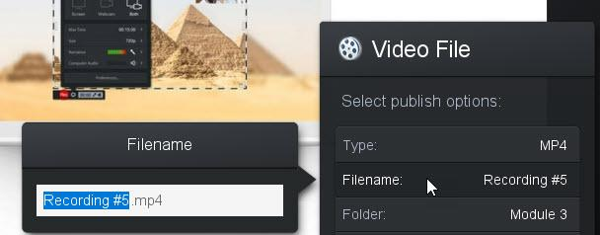

Congratulations! You created a video. We recommend uploading it to your YouTube Channel, then embedding it into your LMS course. Great job!

